1. To get The Country name and Code details code

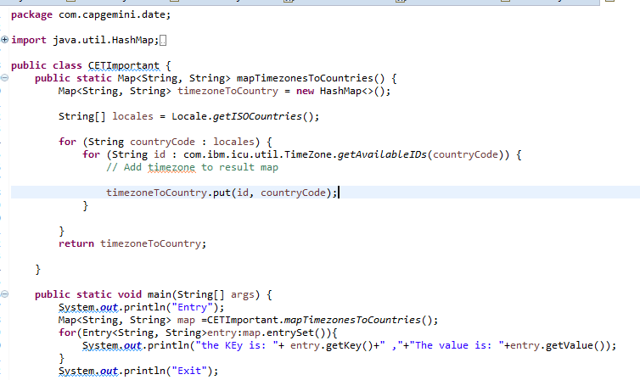

1. Second program to get the Country name, Country code and TimeZone for a given Country code

